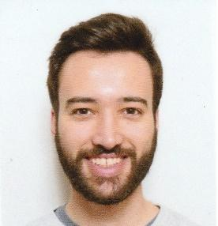
Picture

Professional profile
Graduated in Biotechnology specialized in bioinformatics and just finishing my Master Thesis in Computational Biology focused in a double specialization in “Computational biology and data science” and “Computational-Systems Biology and Genomics”, both at the Polytechnic University of Madrid. I have developed great skills in programming and data analysis due to my professional experience as data scientist.
From my knowledges obtained during my studies in biotechnology and bioinformatics which settle over a strong background in mathematics and statistics, allowing myself to become an skilled data scientist. Just during my bachelor’s I learned how to program in diverse languages like Python, R, SQL, Perl or Basic and other software tools like Linux OS, Github, PuTTY, SPSS, Microsoft Office or Weka. Simultaneously to this period I enhanced myself as person and teammate during my years as professional athlete developing useful skills as collaboration, perseverance, efficiency, planning, decision making and team leadership. Then as professional data scientist I settled my passion for this area which fulfills my interest for both statistics and computer sciences. During this period, I participated in various projects for a finance related entity where I achieved all goals without flaws and greatly enhanced myself as professional. Specifically I conducted data science projects in order to build stock trading recommenders which encompass from data mining and modeling to validation and product deployment. The technologies used during this period were mainly SQL for data management, R for data analysis, Python for modeling and Linux server as OS.
In means of stepping back to improve myself as bioinformatician I left my position to become master student. I feel proud of to have had the opportunity to enrol the Computational Biology master degree as Polytechnic University of Madrid and in specific this master is one of the most requested by postgraduate students in this University. Thanks to this opportunity I learned more about deep learning with Tensorflow and Keras but also text mining and technologies like Hadoop and PySPARK. Technologies which are becoming the standard in industry and make me even more prepared to engage greater projects.

